# DAY 10 part2

1. Write a program in C to Check if the given two matrices are mirror images of one another.

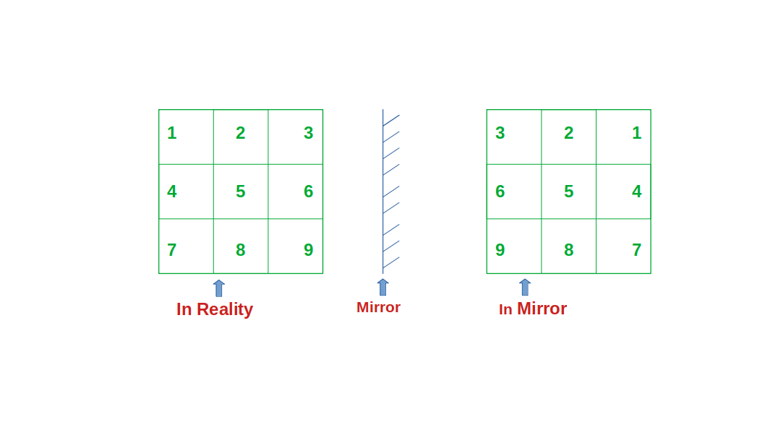

1. Write a program in C to read a two-dimensional array named marks which will store marks of m students in n subjects and will print
2. The marks obtained by each student in different subjects
3. Total marks and average obtained by each student
4. Class average
5. Highest marks in each subject
6. Write a C Program to Interchange any two Rows & Columns in the given Matrix.
7. Write a C Program to Sort Rows of the Matrix in Ascending & Columns in Descending Order.
8. Write a program in C to find saddle point in a matrix. [A saddle point of a matrix is an element which is both the largest element in its column and the smallest element in its row.]